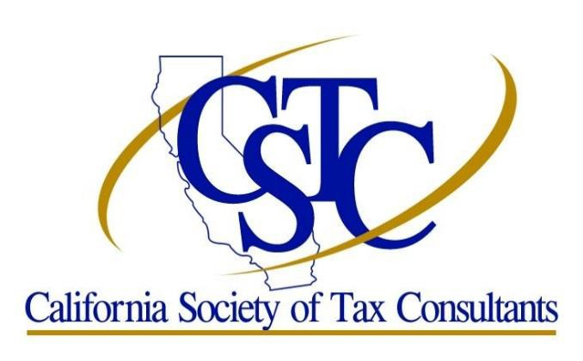
Chapter Contact Michael Locke
Phone: (949) 582-8381
Email: mjlocke@sbcglobal.net

Orange County - South Chapter – November 2020

Monthly Meetings are held on the Fourth Tuesday in January through November

2020 Tax Update - COVID, CARES, PPP, SECURE ACT
OC South County Virtual Chapter Meeting

Date/Time:
Thursday November 12, 2020
4:00 PM to 6:00PM

Location:
Online Meeting via Zoom
This will be Zoom Meeting. Once you register and pay, the Zoom link will be provided for you to log in at the designated meeting time. Zoom does require registration before entering the meeting. Once the meeting is completed, you will receive an evaluation form and your attendance certificate via email.

Topic: 2020 Tax Update - COVID, CARES, PPP, SECURE ACT

Description:
Don't wait until January to try to get up to speed on the new tax laws. With so many new laws and so many changes to those new laws, it's imperative that we stay on top of them so we can answer our clients' questions now as well as offer better tax planning advice. We'll cover the tax aspects and the implications of the new laws and programs -- the CARES Act, COVID-19 relief, the SECURE Act, PPP and EIDL loans, new payroll tax deferrals -- and provide tax-planning tips.

Presenters:
Ruth Godfrey, EA and Linda Dong, EA

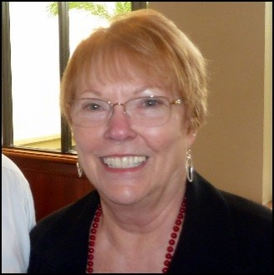 Ruth Godfrey, EA
Ruth Godfrey has been an Enrolled Agent since 1984. She owned her own tax practice from 1981‐2002, formed a partnership in 2001and then incorporated in 2005. She has been a member of the Inland Empire Chapter of CSTC since 1981, and has served CSTC as President of both her Chapter and the Society.She is currently Parliamentarian for CSTC, Chairman of the Audit Oversight Committee for CTEC, and Secretary‐Treasurer for the National Society of Accountants (NSA). Her college major in Psychology has helped her with the counseling needed to guide her clients. She finds real estate one of her favorite areas of tax preparation. Ruth was an active real estate licensee for several years specializing in 1031 exchanges. She prepares approximately 325 individual, business, trust and 990 returns annually. Some actually correctly.

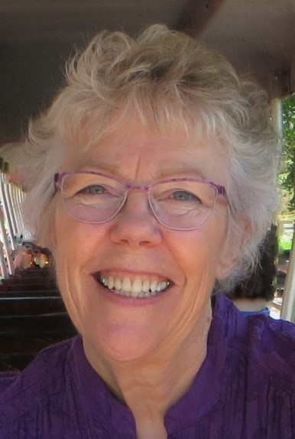 Linda Dong, EA
Linda Dong graduated with honors from the University of Illinois in Chicago with a degree in Accounting. She went to work for the IRS, where she received a very thorough training in taxes and began auditing corporations. Not liking the adversarial relationship inherent in tax audits, Linda left the IRS and started a tax and accounting practice from her home. She grew her practice to include four employees, but eventually downsized and is now once again a sole practitioner working out of her home office. She provides tax and accounting services to individuals, small businesses, and nonprofit organizations. Linda has been an Enrolled Agent (EA) since 1982. Her credentials from the Accreditation Council of Accountancy and Taxation include Accredited Business Accountant (ABA) and Accredited Tax Advisor (ATA). She is a QuickBooks ProAdvisor and frequently teaches classes in accounting and tax to other professionals. Linda is currently serving as First Vice President of the California Society of Tax Consultants and Secretary-Treasurer of the Wine Country Chapter.

CPE Information:
IRS: 18QC1-U-01406-20-O
CTEC: 1000-CE-4812
2 Federal Update hours (Topics covering new tax laws)
Knowledge Level: Intermediate (Basic knowledge helpful)

Cost:
Registration Fee (Member): $20
Registration Fee (Non-Member): $50

2020 California Update
OC South County Virtual Chapter Meeting

Date and Time:
Tuesday, November 17, 2020
4:00 p.m. - 6:00 p.m.

Location:
Online Meeting via Zoom
This will be Zoom Meeting. Once you register and pay, the Zoom link will be provided in your confirmation email for you to log in at the designated meeting time. Zoom does require registration before entering the meeting.

Topic: 2020 California Update
In our California Update presentation the topics to be addressed during this presentation generally include:
•Taxpayers’ Rights Advocate’s Office
•Current Issues
•Legislation
•Bills of Interest
•Conformity
•Earned Income Tax Credit (EITC)
•Audit Issues
•Collection Topics
•Tax Appeals Assistance Program (TAAP)
•Website Redesign
•Communicate with FTB

Speaker: Lila Fedler
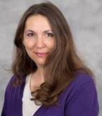Lila Fedler is a Franchise Tax Board spokesperson and serves as a Technical Assistant to the Advocate. Lila is an Enrolled Agent with the Internal Revenue Service and began her career with the Franchise Tax Board in 1980. Lila currently works directly with the Taxpayer Rights' Advocate to assure that the taxpayers have been afforded the protections of the Taxpayers' Bill of Rights. With more than 37 years, Lila has acquired a broad range of experience covering both personal income and corporation tax laws. In addition to her experience as a Franchise Tax Auditor, Protest Hearing Officer, and Audit Technical Specialist and Reviewer, she worked in the private sector as a Senior Manager in the state and local tax practice at a top public accounting firm, headquartered in the West, providing consulting services to public and private middle-market enterprises in many different industries.

CPE Information:
CTEC: 1000-CE-4814
IRS: N/A
2 California hours (Topics covering California law issues)
Registration:
$10 for members
$40 for non-members

Upcoming 2021 Meetings:
January 12, 2021
May 25, 2021
June 22, 2021
July 27, 2021
August 24, 2021
September 28, 2021
October 26, 2021
November 16, 2021

ORANGE COUNTY - SOUTH CHAPTER OFFICERS & DIRECTORS:

President: Lisa Cruz Email: lisarcruz@yahoo.com 949-300-0112
Vice President: Open
Treasurer: Lloyd Boucher Email: lloyd@onefifth.financial 714-928-5109
Secretary: Dee Fix Email: dee@fixtaxaccounting.com 949-440-1900
Director: Guy Liford, EA Email: asktaxguy@yahoo.com 949-683-6311
Director: Michael Locke, EA Email: mjlocke@sbcglobal.net 949-582-8381
Director: Donna Hunt, EA Email: donna@dhtaxacct.com 949-586-6225

CSTC MISSION STATEMENT

To promote professionalism by providing quality educational events for tax professionals, by creating and encouraging networking opportunities for members and by advocating professional standards and positions within the tax industry.

Society Office
65 Enterprise
Aliso Viejo, CA 92656
Phone: 949-715-4192 Fax 949-715-6931
Visit us at www.cstcsociety.org

