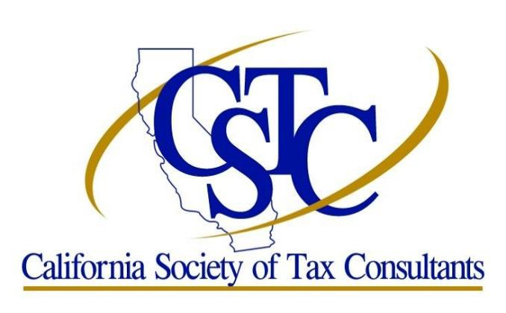
Chapter Contact Michael Locke
Phone: (949) 582-8381
Email: mjlocke@sbcglobal.net

Orange County - South Chapter – December 2020

Monthly Meetings are held on the Fourth Tuesday in January through November

2020 Tax Update - OC South County Virtual Chapter Meeting

Date/Time:
Tuesday, December 15, 2020
5:00 PM to 7:00PM

Location:
Online Meeting via Zoom
This will be Zoom Meeting. Once you register and pay, the Zoom link will be provided for you to log in at the designated meeting time. Zoom does require registration before entering the meeting. Once the meeting is completed, you will receive an evaluation form and your attendance certificate via email.

Topic: 2020 Tax Update – RETIREMENT PLANS & ITIN CHANGES AND UPDATES

Description:
We have been through a lot this year, 2020 and there will be lots of changes in the coming 2021 tax season. Retirement plan is one of them so as changes in ITIN and updates.
Not only federal is implementing changes so as California State for the Retirement plans. SB 78 Individual Healthcare Mandate. AB 2247 Dependent Exemption Credit. AB 93 allows the use of ITIN to establish eligibility of qualifying dependent for CAeitc.

Presenters:
Lloyd Boucher - The Tax Forensics Expert, EA

Lloyd is an Enrolled Agent (EA)

Enrolled Agents are America's Tax Experts. EAs are federally-licensed tax practitioners who may represent taxpayers before the IRS when it comes to collections, audits and appeals. As authorized by the Department of Treasury's Circular 230 regulations, EAs are granted unlimited practice rights to represent taxpayers before IRS and are authorized to advise, represent, and prepare tax returns for individuals, partnerships, corporations, estates, trusts, and any entities with tax-reporting requirements. Enrolled agents are the only federally-licensed tax practitioners who specialize in taxation and have unlimited rights to represent taxpayers before the IRS. The enrolled agent profession dates back to 1884 when, after questionable claims had been presented for Civil War losses, Congress acted to regulate persons who represented citizens in their dealings with the U.S. Treasury Department. Enrolled agents’ expertise in the continually changing field of taxation enables them to effectively represent taxpayers at all administrative levels within the IRS.

Lloyd is a Retirement Income Certified Professional®(RICP®)

RICP®s are America's Retirement Income Experts. RICP®s are experts in building integrated and comprehensive retirement income plans. Their key focus is understanding, choosing, and executing a strategy for generating sustainable income from available resources—whether that means using systematic withdrawals from a portfolio, building an income floor with bonds or annuities, or using a bucket strategy. RICP® is a groundbreaking retirement income planner certification awarded by The American College of Financial Services, a leading financial education institution founded in 1927 by the industry pioneer Solomon S. Huebner.

In developing a sustainable retirement income plan, RICP®s integrate best practices in the areas of

* Social Security claiming

* Evaluating and addressing risks faced in retirement

* Choosing distributions from employer sponsored plans

* Medicare and other health insurance choices

* Planning for long-term care needs

* Choosing appropriate housing

* Income tax and legacy planning

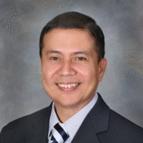

MARIA ELISA R. CRUZ
MBA/Notary Public/IRS ITIN CAA
Lisa graduated Masters in Business Administration from University of Phoenix, Arizona in 2009. She is a candidate for 2021 graduation at Saddleback College for Associate Degree in Accounting.

A detail-oriented Notary Public with years of experience in the Notary, Tax Preparation, Customer Service and Financial Services industry. A finance specialist with extensive experience in customer service and financial services.

Lisa worked at H&R Block as Master Tax Advisor from 2005 to 2011 and started her own tax practice.

Lisa has been an IRS ITIN Certifying Acceptance Agent since 2007 and was able to help thousands of ITIN applicants since 2007.

CPE Information:
IRS: 18QC1-U-01406-20-O
CTEC: 1000-CE-4812
1 Federal Update hours (Topics covering new tax laws)
Knowledge Level: Intermediate (Basic knowledge helpful)
Cost:
Registration Fee (CSTC OC South Member): $0
Registration Fee (Non-Member): $50

Upcoming 2021 Meetings:
January 26, 2021

ORANGE COUNTY - SOUTH CHAPTER OFFICERS & DIRECTORS:

President: Lisa Cruz Email: lisarcruz@yahoo.com 949-300-0112
Vice President: Open
Treasurer: Lloyd Boucher Email: lloyd@onefifth.financial 714-928-5109
Secretary: Dee Fix Email: dee@fixtaxaccounting.com 949-440-1900
Director: Guy Liford, EA Email: asktaxguy@yahoo.com 949-683-6311
Director: Michael Locke, EA Email: mjlocke@sbcglobal.net 949-582-8381
Director: Donna Hunt, EA Email: donna@dhtaxacct.com 949-586-6225

CSTC MISSION STATEMENT

To promote professionalism by providing quality educational events for tax professionals, by creating and encouraging networking opportunities for members and by advocating professional standards and positions within the tax industry.

Society Office
65 Enterprise
Aliso Viejo, CA 92656
Phone: 949-715-4192 Fax 949-715-6931
Visit us at www.cstcsociety.org

